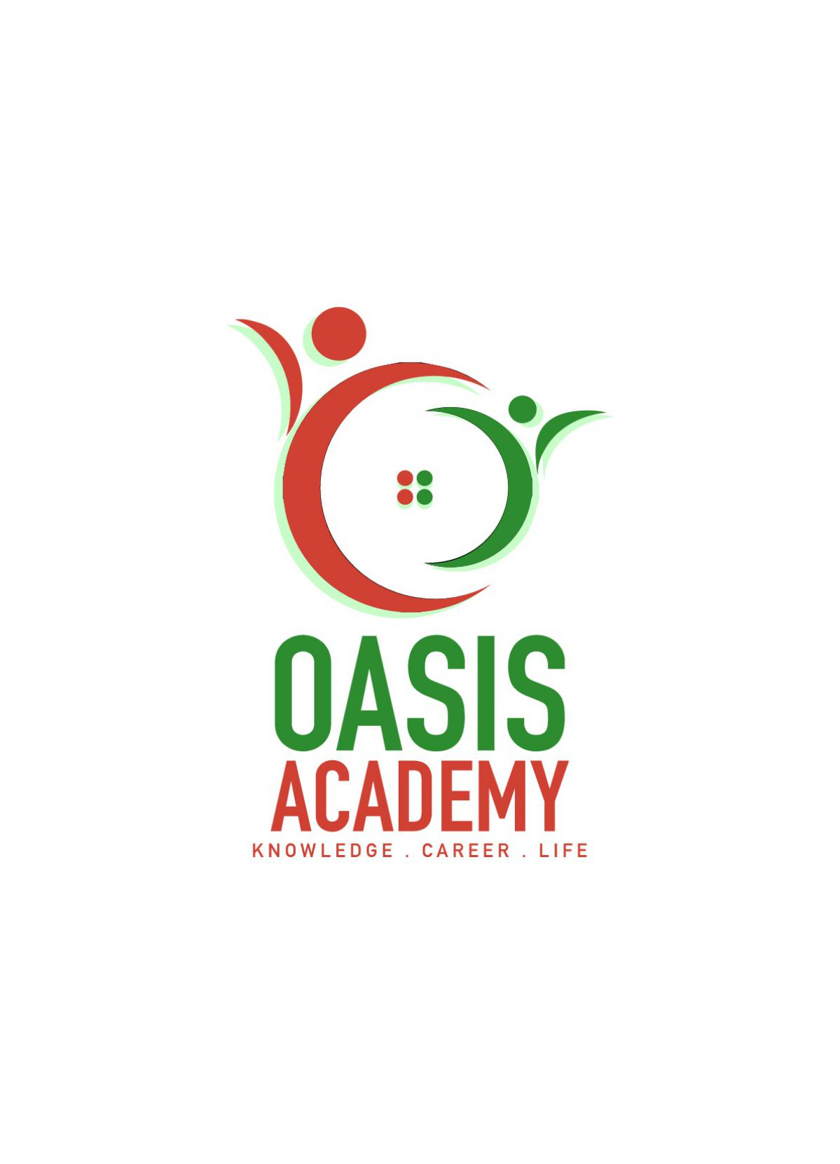

Name: KARTHIK RAJU

Login ID: karthik@oasis-portal.com

Course title: THE TOURISM AND HOSPITALITY

Subject Code: BHM04

Submitted date:

**Table of Contents**

|  |  |  |
| --- | --- | --- |
| **No** | **Details** | **Page** |
| 1 | Executive Summary | 2 |
| 2 | Introduction | 3 |
| 3 | Assignment Question |  |
|  | Part 1 | 4,5,6,7,8 |
|  | Part 2 | 9,10 |
|  | Part 3 | 11,12,13 |
|  | Part 4 | 14,15 |
| 4 | Conclusion | 16 |
| 5 | References | 17 |
|  |  |  |

**Executive Summary**

In this part, I’m will explain about THE TOURISM AND HOSPITALITY. In a basic explanation of the module, but I am also briefing about in define about tourism and hospitality;which is explain my understanding about hospitality industry. The second part is brief on different type of Tourism categories and also defining the Tourism. In third part, I am describing the lodging accommodation and the types of Hotel accommodation. Last but not least, I will be explain about the Significant of Entertainment in this industry. These are the things that I will be show in this assignment. Each part consists its briefing and also with some relevant examples.

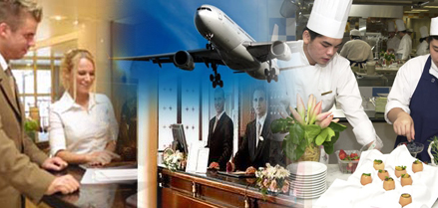

**Introduction**

In this part, I am going to learn about tourism and hospitality industry in basic way. And also I am going elaborate that what I learned it. The assignment consists of four questions. In this assignment, I answering to the each and every question in brief explanation and relevant examples with also some pictures to make my presentation looks good. The question one is define the tourism and hospitality and explain my understanding about hospitality industry. The second is have to brief on different type of tourism categorizes and defining tourism. The third part is about describe the lodging accommodation and types of hotel accommodation. Last but not least , the fourth question is I should explain the significant of entertainment in this industry. The way of my presentation in this assignment will be in essay but I will give in a brief explanation and suitable examples.

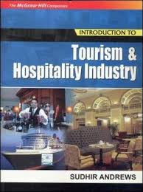

**Assignment Questions**

**Question 1**

Define the Tourism and Hospitality. Explain your understanding about the Hospitality industry.

TOURISM is a activity of travelers such as traveling, staying, and lodging. Tourists always search for a comfort zone for their living. They need a suitable shelter for their priority. Tourists always are expecting the comfort shelter such as hotels, motels, villa, and many more. But they will not stay all their entire life, maybe certain days, months or years. The timing of their living will maybe more than a year or less than a year.

Tourism are also very essential for many countries,by this concept. By this concept only, they can attract other country people to make them come over to other country. And also this concept, generating a big income for country. This concept providing lots of consumption of goods and service by tourists. The tourism is a system consists of three different elements, which is people, geographical, and tourism industry. 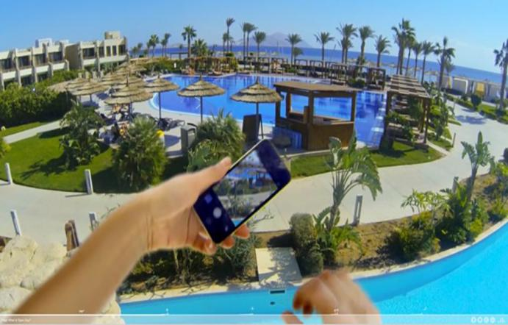

The tourism and hospitality also consists of leisure system, recreational system, adventure system, health system, and education system. The leisure industry is the segment of business focused on recreation, entertainment, sports, and tourism services. The field has developed to the point of have education and disciplines focused on it, such as the universities and hotels.

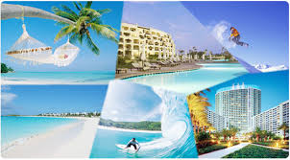

In recreational system is expected to be the fastest-growing tourism sector in the field, with an annual employment growth. The key component of the tourism industry is attractions, which offer visitors a chance to explore the sights, facilities and wonders of their destination. Attractions generally include historical sites, heritage, homes, museums, hall of fame, art galleries, botanical gardens, ski hills, aquariums, zoos, water parks, amusement parks, casinos and cultural attractions.

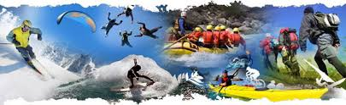

Further more, in adventure industry/adventure travel is successful and the industry is adapting accordingly. Destinations such as Cuba, Colombia, Burma, Mexico, Brazil, and Jordan have become more popular with tourists as adventure travel rises. The adventure travel is mainly reason for tourists like hungry for experience, saving time, baby-boom backpackers, and striking a compromise.



The health system in tourism is for traveling for health and wellness is one of the most important tourist patterns of economic returns generated by the tourism industry, tourist destinations and the health sector. Health and wellness tourism provides the tourists or their companions with the opportunity to visit the tourist attractions in the region and enjoy the interesting tourism trips during the treatment journey. Importance of this section, is the reasonable prices, quantity and quality, availability of latest medical technology, personal services and no waiting for their services.



Lastly in this industry also important of education system. Because of the travel and tourism is a service sector which suggests, the skills are far more important than that of the academic knowledge. It is very important for the students to get the skills before getting into their job and in this industry also.



HOSPITALITY industry is a huge industry. In this industry mainly focusing the relationship between the guest and a host. A host must treat a guest with good will by providing reception area and adventure area. Host always have to service to guest, visitors and strangers. The hospitality industry also is a broad category of fields within service industry that includes lodging, event planning, theme parks, transportation, cruise line and additional fields within the tourism industry. This industry is responsible for providing primarily food services accommodations in places such hotels, resorts, conference center and theme or amusement parks.

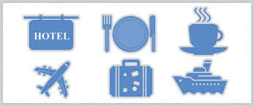

The TOURISM AND HOSPITALITY consists of lodging, staying, travel like travel agency, recreation like lakes, amusement like museums, attraction like Marina Bay Sands, resorts like Shang-ri La resort and food beverage like restaurants.this industry is a largest employment rate usually in a country.

TOURISM PRODUCTS are those products which can be sold in tourism market. It can be anything which provides satisfaction during the course of visit of the particular tourist. An action, event or experience in some tourists activities and which utilizes the natural and cultural resources of the country. The tourism products contained 6A’s which is access, accommodation, attractions, activities, amenities and ancillary services.

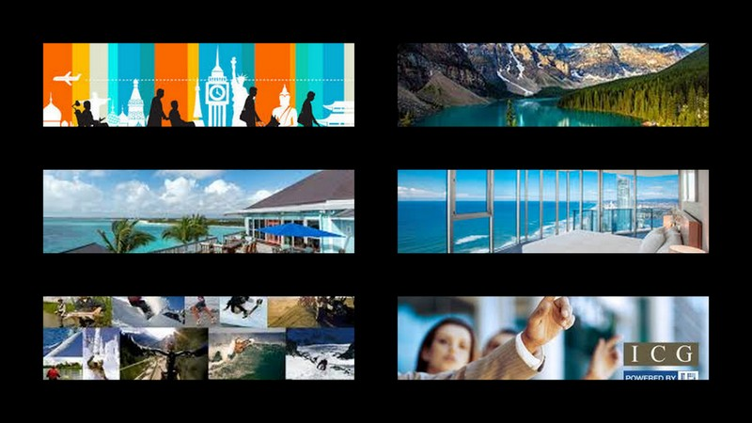

Access is the ongoing enterprise to ensure tourist destinations, products and services are accessible to all people, regardless of their physical limitations, disabilities or age. It encompasses publicly and privately owned tourist locations. Example of this product is like transportation. Accommodation is one of the basic needs for any tourism activity. Travelers tourists need lodging for rest, while they are on a tour. Accommodation in the form of low budget lodges/hotels to world class luxury hotels is available at all the major tourist destinations to provide the tourist a home away from home.

Attractions is a place of interest where tourists visit, typically for its built-in or exhibited natural or cultural value, historical significance, natural or built beauty, offering leisure, adventure, amusement, and with hotel facilities. Activity in tourism product is defined as the activities of person identified as visitors. A visitors is someone who is making a visit to a main destination outside his/her usual environment for less than year for any main purpose holidays, leisure and recreation, business, health, education or other purposes like festivals and events.

Amenities are elements of comfort and convenience, most often in reference to a house, vehicle, resort, or rental. An example of amenities are a hot tub and room service in a hotel and essential facilities. Amenities are defined as rule and good manners. Ancillary services means the extra service related to travel and tourism such as car hire, insurance,tour guides and accommodation. Ancillary services refers to organization that do not have direct role in travel and tourism, but plays a supporting role, perhaps offering related products and services.

FIELD OF SERVICES IN TOURISM AND HOSPITALITY INDUSTRY is a broad category of fields within services industry that includes lodging, event planning , theme parks, transportation, cruise(ship) line, and additional fields within the tourism industry. The hospitality industry that depends on the availability of leisure time and disposable income. A hospitality unit such as a restaurant, hotel, or an amusement parks consists of multiple groups such as facility maintenance and direct operations in restaurants and bars, like night club, pubs and public houses. For travel like travel agents, tour operators and leisure centers.

**Question 2**

Brief on different type of Tourism categories. Define tourism.

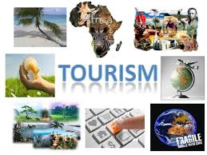

Leisure tourism is travel in which the primary motivation is to take a vacation from everyday life. Leisure travel is often characterized by staying in nice hotels or resorts, relaxing on beaches or in a room or going on guided tours and experiencing local tourist attractions. Most meals are eaten out when traveling for pleasure, and often more expensive modes of transportation, such as taxis, are used to get around. In some cases, leisure travel might be used to refer to any trip that lasts more than a week, regardless of the primary focus. Leisure travel is general seen as the opposite of business travel.

Cultural tourism is important for various reasons; it has a positive economic and social impact, it establishes and reinforces identity, it helps build images, it helps preserve the cultural and historical heritage, with culture as an instrument it facilitates harmony and understanding among people, it supports culture and helps renew tourism.

Religious tourism also commonly referred to as faith tourism , is a type of tourism, where people travel individually or in groups for journey, missionary, or leisure purposes. Modern industry tourists are more able to visit holy cities and holy sites around the world. Religious tourism has existed since antiquity. This religious tourism is also to understand and appreciate their religion through a tangible experience; to feel secure about their religious beliefs, and to connect personally to the holy city.

Health tourism refers to people traveling to a country other than their own obtain medical treatment. In the past this usually referred to those who traveled from less-developed countries to major medical centers in highly developed countries for treatment unavailable at homes. However, in recent years it may equally refer to those from developed countries who travel to developing countries for lowed priced medical treatments. The motivation may be also for medical services unavailable or illegal in the home country.

Sport tourism refer to travel which involves either observing or participating in a sporting event staying apart from their usual environment. Sport tourism is a fast-growing sector of the global travel industry. Sport tourism is a rapidly growing corner in the travel or tourism industry.

Educational tourism then comes in a great variety of formats, places seeking to enhances their educational tourism product however have to first consider who their market is and what they have to teach others that is special or unique. Educational tourism is a way to use better our facilities. Educational tourism offers another major advantage. It does not need to be weather dependent, a community does not need special geography and usually most of the needed infrastructure is already in place in order to take advantage of these educational tourism products consider.

Business tourism or business travel is a more limited and focused subset of regular tourism. During business tourism (traveling), individuals are still working and being paid, but are doing so away from both their workplace and home.some definitions of tourism look to exclude business travel. And also defines tourists as people traveling to and staying in places outside their usual environment for not more than one consecutive year for leisure, business and other purposes.

Alternative tourism is the opposite of mass organized tourism. Alternative tourism involves travel that is personal and authentic and encourages interaction with the local environment, people and communities. Alternative tourism includes package tours and individual tourist services.

TOURISM is a dynamic and competitive industry that requires the ability to adapt constantly to customers changing needs and desires, as the customer’s satisfaction, safety and enjoyment are particularly the focus of tourism businesses. Although many of us have been tourists at some point in our lives, defining what tourism actually is can be difficult. Tourism is the activities of people traveling to and staying in places outside their usual environment for leisure, business or other purposes for not more than one consecutive year.

**Question 3**

Describe the lodging accommodation and types of Hotel accommodation.

Lodging accommodation is huge sector in hospitality industry. This sector features their guest with a gamut.the guest always need a shelter for their priority; the way they search is by nearest or the quality of the shelter. Examples hotels are divided into many level such as 1 to 5 star, but the level has been increased to 7 star hotels like in Dubai, India. The levels are also called as luxury hotels to moderate hotels.

As seen accommodation is a broad sector of hospitality. Accommodation is not only providing a shelter like a room or house, and also need the uses such as bed, and other hotel facilities. One more thing is more efficient in this, it is breakfast. Most of the hotels are now providing free breakfast services to their all guest. By the way, the other point is in this sector is customer service. Customer service is more important in providing accommodation services. This service have to be fulfilled by the customer needs and efficiency, and have to be comfort to the customer in all way, and lastly customer’s always need their needs on time, so the punctuality have to be in the character of a host.

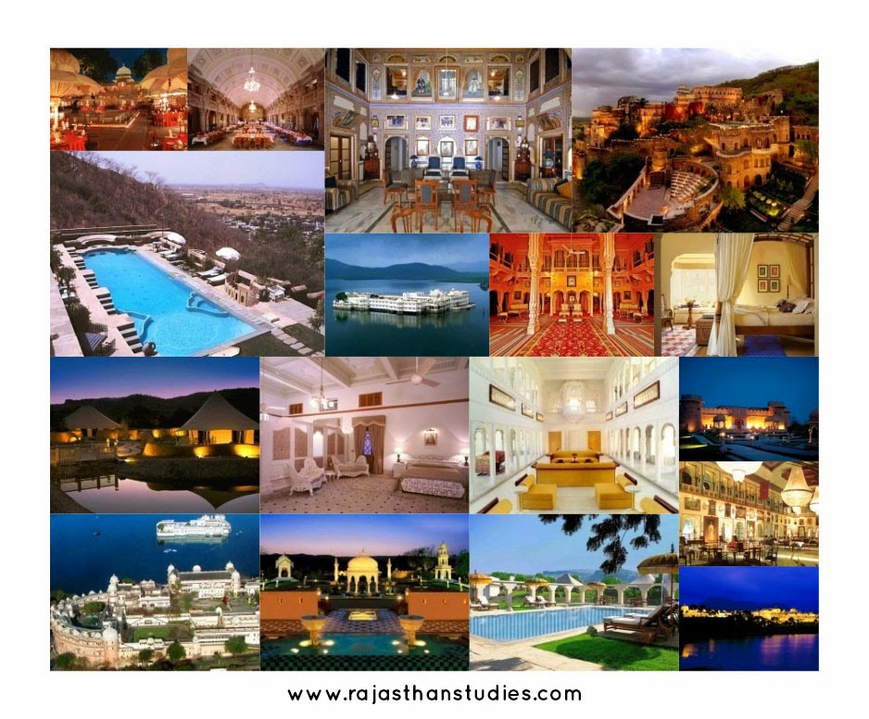

**Types of hotel accommodation**

Hotel

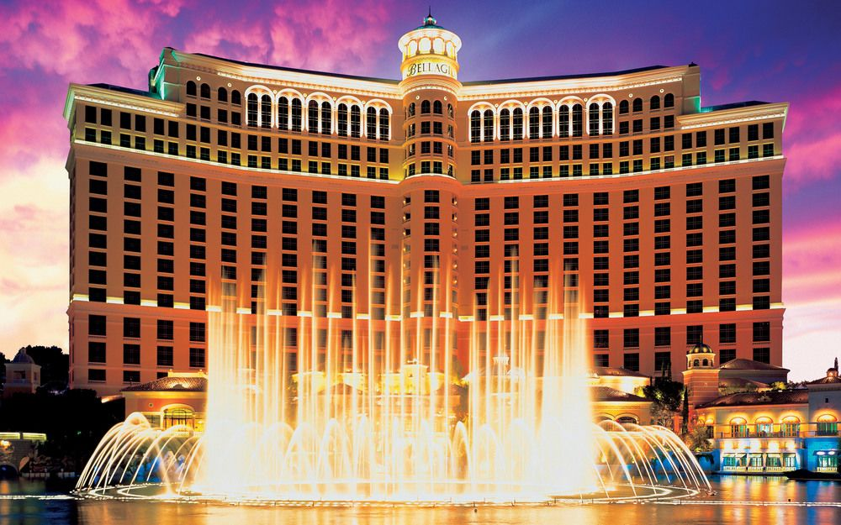

3600 Las Vegas Blvd S, Las Vegas, NV, 89109, United States of America (Hotel Bellagio)

An establishment that provides travelers with paid accommodation and other guest services. Depending on size, location, and amenities, hotels are generally rated from one-star to seven-stars, but letter grading;from A to F, and other rating schemes are also used to categorize hotels across the world.

Timeshare

Welk Resorts San Diego Timeshare 2005

[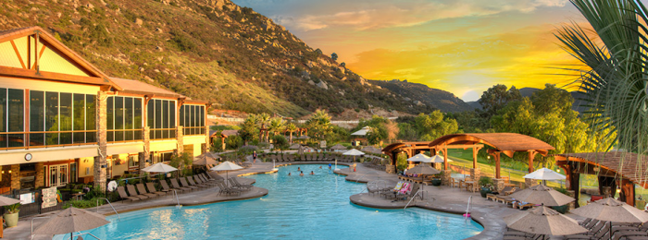](http://timesharereviewguys.com/wp-content/uploads/2014/11/welk.png)

Usually located in a sought-after destination, a timeshare is a type of vacation property with shared ownership and use rights. The term first appeared in the United Kingdom during the 60’s and has multiple variations today, both in style and the type of proprietorship. Moreover, choosing a timeshare for rent can be smart alternative to staying in a hotel room, offering superior amenities and better value.

Resort

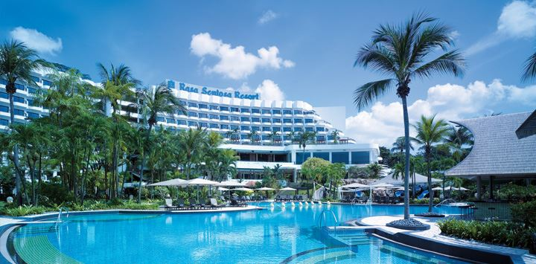

Shang-Ri La Resort Singapore

Although a resort is primarily known as destination frequented by vacationers in search of relaxation and entertainment, the term is also used to describe a full service lodging establishment that offers extensive guest services and recreational services.

Palazzo

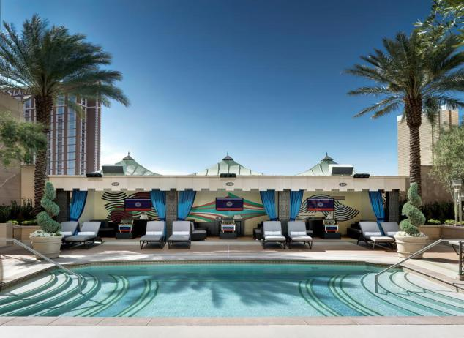

The Palazzo Resort Hotel Casino

Although often translated to palace, the word palazzo has a broader meaning in Italy. It can be anything from a block of flats to the home of a noble family to a historic hotel. From an architectural point of view, however, palazzo describes a grand, imposing building belonging to the Renaissance style.

Masseria

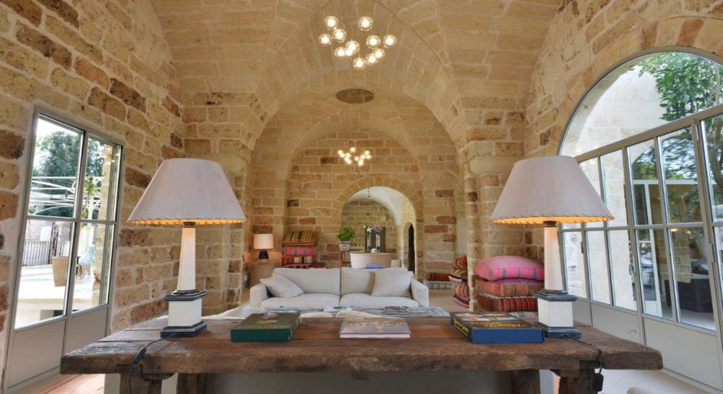

### [Masseria Trapanà](http://www.telegraph.co.uk/travel/destinations/europe/italy/puglia/hotels/masseria-trapana-hotel/) Surbo, Puglia, Italy

### A masseria is a large, fortified farm typical to Southern Italy, mainly the region of Puglia. Set in working farms, most of these country houses have been transformed into rustic Bed & Breakfasts, self-catering vacation rentals, and even luxurious hotels. Due to the large number of massearie, the coastel area between Bari and Brindisi is sometimes referred to as the Masseria Coast.

**Question 4**

Explain the Significant of Entertainment in this industry.

Entertainment is a form of activities that take away people’s stress basically come from work or school and give them properly amusement to relax. In tourism industry, entertainment is very important sector. Tourists would love to visit some specific places such as movie theaters, water park, Carnival and so on. In Fredericton area, we have places for entertainment like Regent mall and Kingswood. Tourism is the largest group of employment , and it happens to be the most diverse. Some jobs in recreation and entertainment field include actors, actresses, movie theater manager, google employee, Casino Dealer, Museum Curater, ski instructor and so on.

Types of Entertainment

Marina Bay Sands

**Marina Bay Sands** is an integrated resort fronting Marina Bay in Singapore.Marina Bay Sands is a premier entertainment destination with its vibrant diversity of attractions and facilities. The vision was to build an integrated development that is timeless, a landmark that possesses a distinct identity which distinguishes Singapore from other cities.Located along the Marina Bay waterfront, Marina Bay Sands features three cascading hotel towers topped by an extraordinary sky park, 'floating' crystal pavilions, a lotus-inspired Museum, retail stores featuring cutting-edge labels and international luxury brands, trendy Celebrity Chef restaurants, endless entertainment at the theatres, the hottest night clubs and a Las Vegas-style casino. Business visitors will also enjoy the extensive Meetings, Incentives, Conventions and Exhibitions (MICE) facilities featuring state-of-the-art technology, highly flexible exhibition halls, and a convention centre that can host over 45,000 delegates.Marina Bay Sands seamlessly combines business and leisure into a singular destination unlike any other.

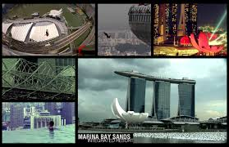

**Conclusion**

In this part, I have learn a lot about the tourism and hospitality industry.The hospitality and tourism industry has grown magnificently around the world. In Singapore alone, I’ve seen the rise of the integrated resorts, Gardens by the Bay, Universal Studios and more.But first and foremost, the industry will always be about happiness. Whether it’s welcoming someone to a new country, or helping a guest get acquainted to his hotel room, or managing a large tour group, it’s about bringing a smile to faces and laughter to their hearts.We were the first in Singapore or worldwide to offer a hospitality and tourism diploma, and as such the course is well-plugged into a large network of resources within the industry. If working to bring joy to others is my passion, I welcome you with open arms - not as guests, but as family.

**References**

* **<https://in.hotels.com/ho119566/bellagio-las-vegas-united-states-of-america/>**
* **<http://timesharereviewguys.com/timeshares/welk-resorts-san-diego-timeshare/>**
* [http://www.marinabaysands.com/company-information/about.html#iTLvo1PXbywfArif.97](http://www.marinabaysands.com/company-information/about.html" \l "iTLvo1PXbywfArif.97" \o "http://www.marinabaysands.com/company-information/about.html#iTLvo1PXbywfArif.97)
* [Entertainment Sector in Tourism by Unknown Unknown on Prezi](https://prezi.com/egtamtawbo6u/entertainment-sector-in-tourism/" \o "Entertainment Sector in Tourism by Unknown Unknown on Prezi)
* [http://www.luxuryaccommodationsblog.com/](http:/www.luxuryaccommodationsblog.com/)
* <https://www.careerguide.com/ask/t/top-institutions-of-hospitality-and-tourism-management-education-in-india>
* <http://www.luxuryaccommodationsblog.com/types>
* <https://www.go2hr.ca/bc-tourism-industry/what-tourism/recreation-and-entertainment>
* <https://www.slideshare.net/roopeshv149/attraction-shopping-entertainment-components-of-tourism>

THE END